(Approx. 283 words)

Locate files and folders instantly!
By Jasmine Blue D’Katz, Lake County Area Computer Enthusiasts
www.lcace.org
jj1450xl (at) yahoo.com

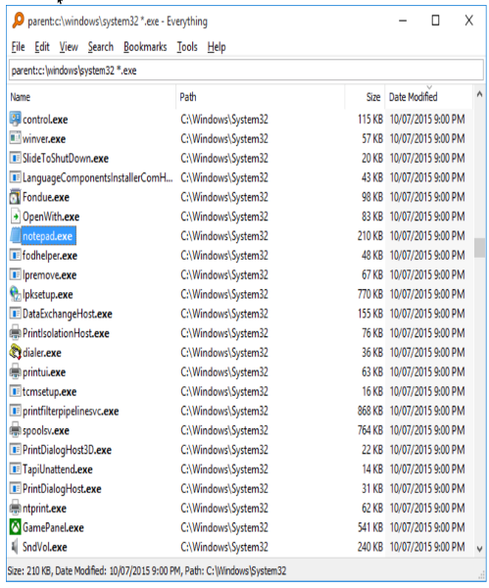
I have been watching Tech for Seniors for several months, and like attending our monthly club meeting, I learn about different programs available to make using my computer easier. Recently, during his Evernote presentation, one of the TFS hosts was asked a question about finding files and folders on his computer. He suggested and showed a program called Everything.

Everything is a piece of Windows software that bypasses Windows search, and in the blink of an eye, it gives you a list of all files and folders on your local storage device. If that is what you want, then basically that is what it does, and it is efficient, effective, stable, and uses low system resources.

When I run Everything, it creates an index of all the files and folders on my machine. Now I am talking about indexing a 4 TB hard drive that may have millions of files, but this program is wicked fast. Furthermore, the searching is done in real-time.

The screen display can be shown with several different files: Name, Path, Size, Last Write Time, Creation Time, Last Access Time, and Attributes. Sorting by any field will take a little longer than the search.

You no longer must struggle with Windows search again to find files on your disorganized system so you might want to give Everything a try.

The best part of Everything is it is a FREE download and works with Windows 10, 8, 7, and XP. Everything is a simple app and one of the most useful ones I use on my computer. Everything - Download (softonic.com)

